COURSE PROJECT

DESIGN DIRECT
A course project report submitted in partial fulfilment of the requirement of
DEVOPS AND FULLSTACK

By

Badavath Sarayu Naik 2303A510A6

Under the guidance of
Dr. N.VENKATESH
Asst. Professor, Department of CS & AI



SR University, Warangal
APRIL-2026

Chapter No. Title Page No.

1 INTRODUCTION 01
1.1 About the Project 01
1.2 Objectives 02
1.3 Scope of the Project 03

2 LITERATURE REVIEW 04
2.1 Overview 04
2.2 Related Studies and Existing Solutions 05
2.3 Tools and Technologies Used 06

3 METHODOLOGY 07
3.1 System Architecture 07
3.2 System Workflow 08
3.3 Data Handling and Storage 09

4 RESULTS AND DISCUSSION 10
4.1 System Implementation 10
4.2 Key Features 11 4.3 System Evaluation 12

5 CONCLUSION AND FUTURE WORK 13
5.1 Summary of Findings 13
5.2 Conclusion 14
5.3 Future Enhancements 15

ABSTRACT
The Fashion Designer Marketplace is a web-based platform developed to connect customers with professional fashion designers through an online marketplace. The primary objective of this system is to simplify the process of discovering designers, booking fashion services, and managing design orders digitally.
Traditional methods of finding fashion designers often require customers to visit local boutiques or rely on personal recommendations. This platform eliminates those limitations by providing a centralized online system where designers can showcase their portfolios, services, and pricing details while customers can easily browse, compare, and book designers.
The system is developed using modern web technologies including HTML, CSS, JavaScript, Node.js, and Express.js. It provides core functionalities such as user registration, designer profile browsing, appointment booking, simulated payment processing, and order tracking.
The project demonstrates the implementation of a service-based digital marketplace with a responsive and user-friendly interface. The platform improves accessibility to fashion design services and provides an efficient medium for communication and collaboration between designers and customers.

Page no:01
CHAPTER 1 INTRODUCTION

1.1 About the Project
The Fashion Designer Marketplace is an online platform designed to connect customers with professional fashion designers. In traditional systems, customers often face difficulties in identifying suitable designers for customized clothing or fashion consultation. Most people rely on local boutiques, personal contacts, or manual visits to find fashion designers.
This project addresses these challenges by creating a centralized digital marketplace where designers can display their services and customers can easily browse and book appointments.
The platform allows designers to create professional profiles that include:
- Design specialties
- Portfolio images
- Pricing details
- Customer ratings and reviews
Customers can explore these profiles, compare services, and schedule appointments according to their preferences. Additional features such as booking confirmation, simulated payments, and order tracking enhance the overall user experience.
The application is designed as a responsive web-based system that works efficiently on desktops, tablets, and mobile devices.

Page no:02

1.2 Objectives

The main objectives of the Fashion Designer Marketplace project are:
- To develop an online platform that connects customers with fashion designers.
- To allow designers to showcase their portfolios and services.
- To provide customers with the ability to browse, compare, and select designers easily.
- To implement a booking system for consultations, fittings, and design services.
- To simulate payment processing for service bookings.
- To provide an order tracking system that displays the progress of design and delivery.
- To create a responsive and user-friendly web interface.
- To demonstrate full-stack web development concepts using modern technologies.

Page no:3

1.3 Scope of the Project

The scope of the Fashion Designer Marketplace is to provide a digital platform where customers and designers can interact efficiently.
The system supports two types of users:
Customers
Customers can:
- Register and log in to the system
- Browse available designers
- View designer portfolios
- Book appointments
- Track order progress
Designers
Designers can:
- Create and manage profiles
- Upload portfolio images
- Display service details and pricing
Currently, the system uses LocalStorage to store user and booking data within the browser. In future versions, the system can be enhanced with database integration, real-time communication, and secure online payment systems.

Page no:04

CHAPTER 2 LITERATURE REVIEW

2.1 Overview
Digital marketplaces have become an essential component of modern business ecosystems. These platforms connect service providers with customers through online interfaces, reducing the need for physical interactions.
In recent years, online marketplaces for freelancers, designers, and creative professionals have gained significant popularity. These platforms provide opportunities for independent professionals to reach larger audiences and showcase their work.
Fashion marketplaces specifically help designers promote their work while allowing customers to access multiple designers in a single platform.
The Fashion Designer Marketplace project applies the digital marketplace concept to the fashion industry by enabling personalized fashion services through an online platform.

Page no:05

2.2 Related Studies and Existing Solutions

Several online platforms provide fashion-related services and products. Many platforms allow designers to sell clothing items online or offer freelance services.
However, most of these platforms focus primarily on ready-made fashion products rather than customized design services.
Research studies indicate that platforms offering personalized services and direct interaction with designers improve customer satisfaction and engagement.
The Fashion Designer Marketplace focuses on customized fashion services, including:
- Fashion consultation
- Measurement collection
- Fittings
- Personalized clothing design

Page no:06

2.3 Tools and Technologies Used
The following technologies are used in the development of this project:
HTML5
HTML is used to create the structure of the website, including forms, navigation menus, designer profiles, and booking pages.
CSS3
CSS is used to design the user interface with modern layouts, responsive design, animations, and color styling.
JavaScript
JavaScript is used to implement interactive features such as dynamic content updates, booking forms, modal windows, and notifications.
Node.js
Node.js is used as the server-side runtime environment to run the web application.
Express.js
Express.js is a lightweight framework used to create the server and manage routing.
LocalStorage
LocalStorage is used to store user data and booking information within the browser.

Page no:07

CHAPTER 3: METHODOLOGY 3.1 System Architecture
The Fashion Designer Marketplace is developed as a web-based application consisting of a frontend interface and a backend server. The frontend is built using HTML, CSS, and JavaScript, while Node.js and Express.js are used to serve the application.
The system architecture consists of the following components:
- User Interface (Frontend)
- Web Server (Node.js)
- Application Logic (JavaScript)
- Local Data Storage (LocalStorage)
Users interact with the system through the web interface, and the application processes their actions using JavaScript functions.

3.2 System Workflow
The system workflow follows several steps:
- The user registers or logs into the platform.
- The user browses the list of available fashion designers.
- The user views designer profiles, portfolios, and ratings.
- The user selects a designer and books an appointment.
- The system displays payment details and confirms the booking.
- The user can track the order status through different stages.
This workflow ensures a smooth and structured process for booking fashion design services.

Page no:08

3.3 Data Handling and Storage
The system uses LocalStorage to store user data and booking details in the browser.
JavaScript functions are used to:
- Create new data entries
- Retrieve stored data
- Update booking details
This approach simplifies the system architecture and demonstrates client-side data management without requiring a database server.

Page no:09

CHAPTER 4: RESULTS AND DISCUSSION 4.1 System Implementation
The Fashion Designer Marketplace was successfully implemented as a web application with multiple interactive features. The platform allows users to perform actions such as registration, browsing designers, booking appointments, and tracking orders.
The system interface is designed to be responsive and visually appealing. Users can easily navigate between sections such as featured designers, booking forms, and order tracking.

Results:
Code: node server.js
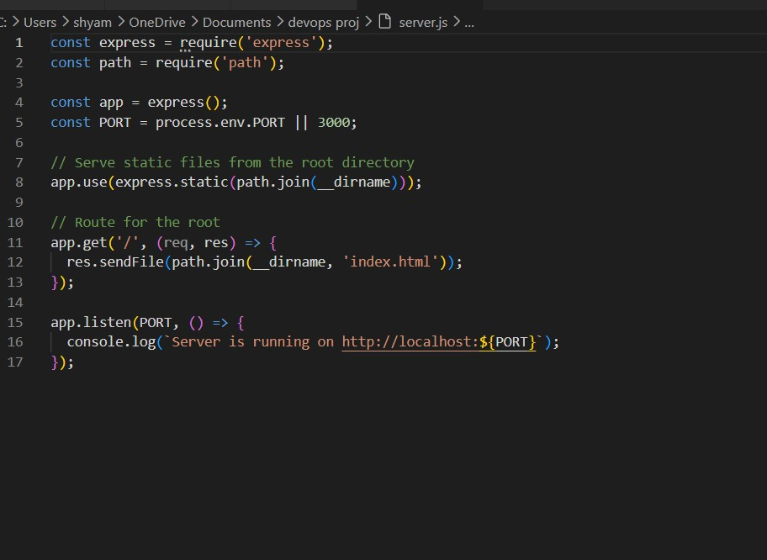

Page no:10

Home page :
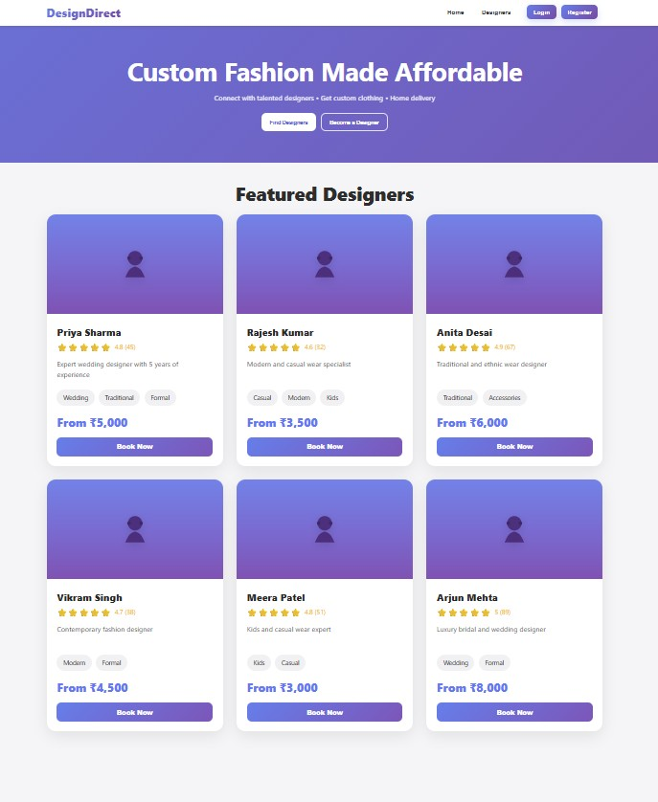

Page no:11

Register page :

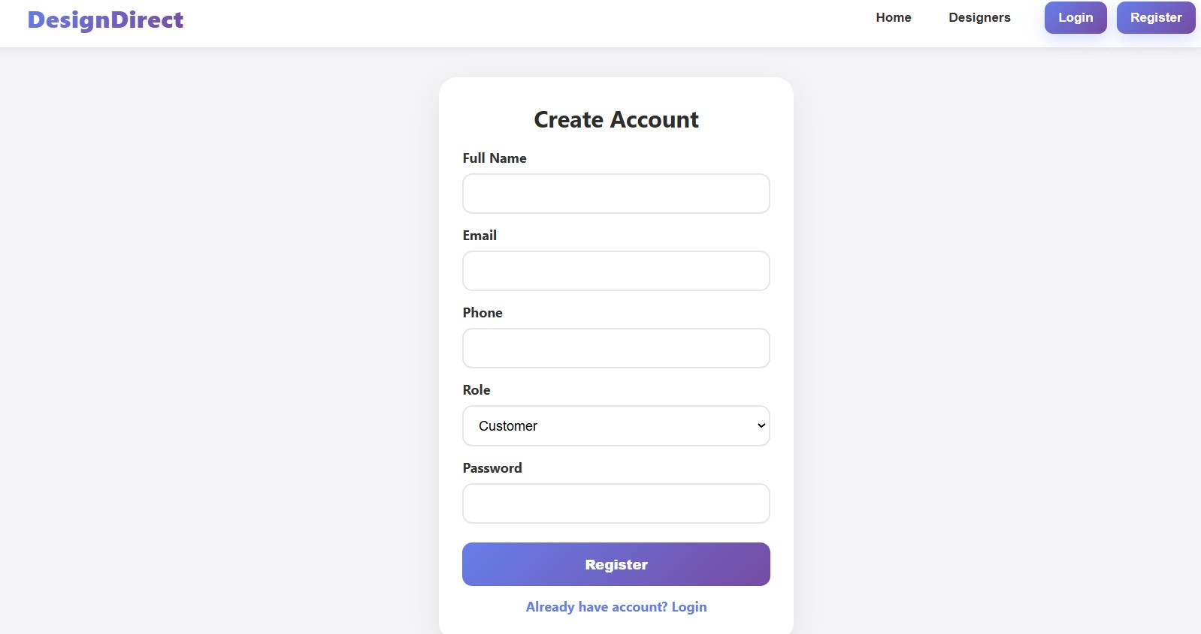

Login page:

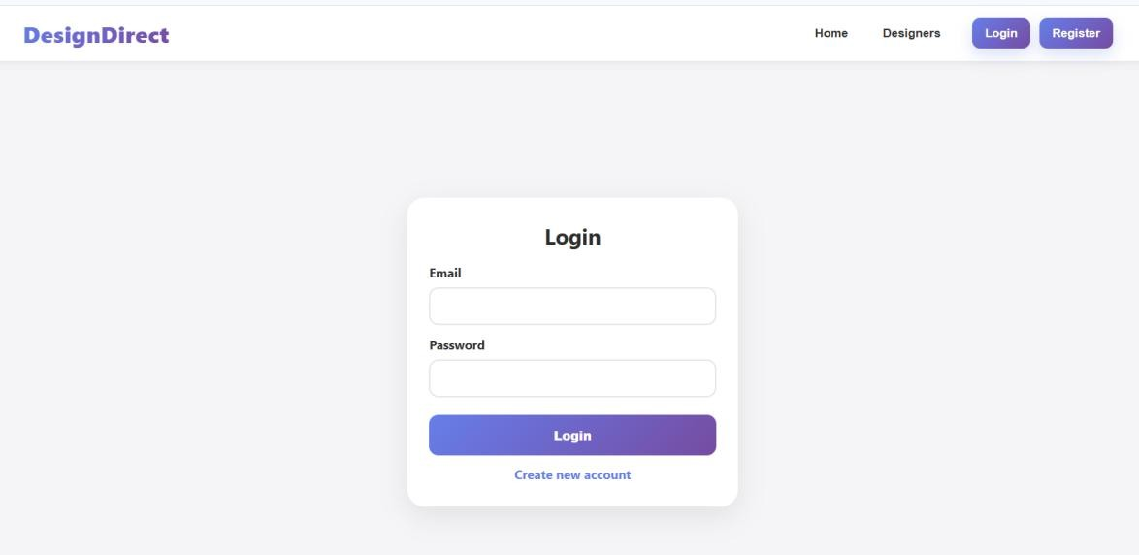

Page no:12

DesignDirect :
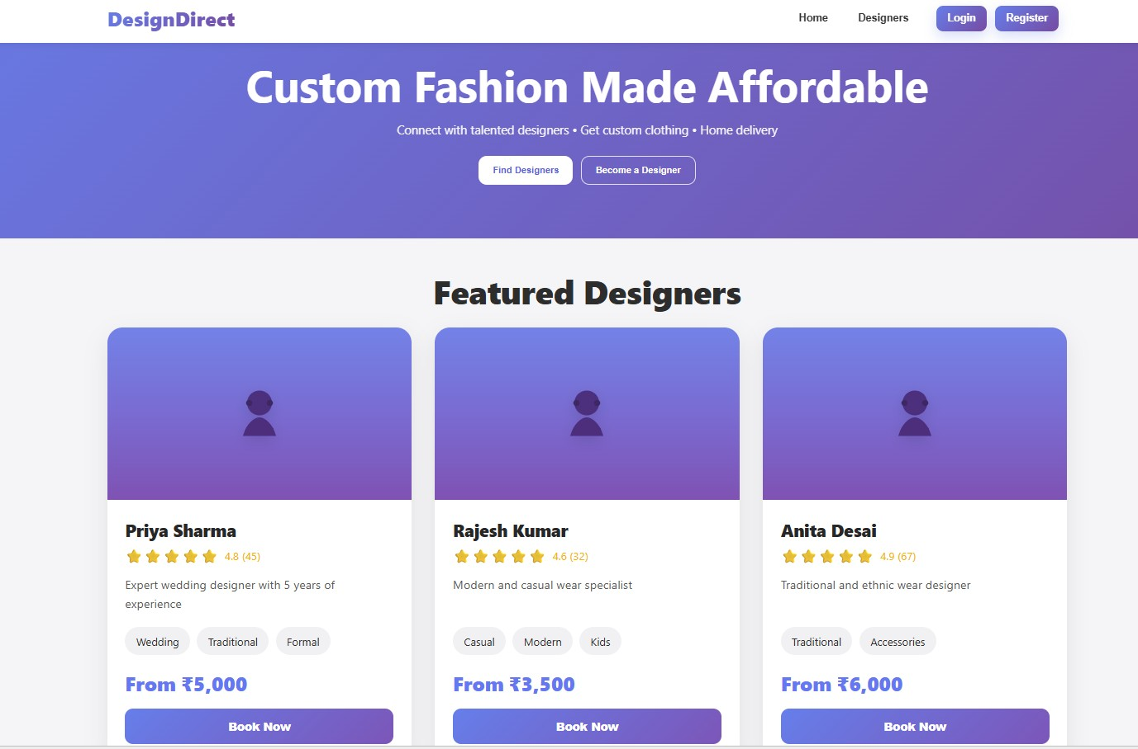

4.2 Key Features
The system includes several important features:
- User registration and login system
- Designer profiles with specialties and ratings
- Portfolio showcase
- Appointment booking system
- Payment breakdown calculation
- Order tracking timeline
- Notification messages for user feedback
- Responsive design for mobile and desktop devices

Page no:13

4.3 System Evaluation
The project demonstrates how a digital fashion marketplace platform can be implemented using modern web technologies such as HTML, CSS, JavaScript, Node.js, and Express.js. These technologies enable the development of a responsive and interactive web application that allows users to perform multiple operations efficiently within a single platform.
The platform successfully provides a convenient system where customers can discover designers, book services, and track their orders. By integrating multiple functionalities into a unified interface, the system simplifies the process of accessing fashion design services. Customers no longer need to visit multiple physical stores to find designers, as the platform provides a centralized environment where designers and customers can interact digitally.

Page no:14

CHAPTER 5:
CONCLUSION AND FUTURE WORK

5.1 Summary of Findings

The Fashion Designer Marketplace successfully demonstrates the concept of a service-based online marketplace. The system provides a user-friendly platform where customers can discover fashion designers, book services, and track their orders.
The project also showcases practical implementation of web development concepts including frontend design, interactive user interfaces, and basic backend integration.

5.2 Conclusion

The project highlights the potential of digital platforms in improving access to fashion design services. By providing a centralized marketplace, the system simplifies the process of connecting customers with designers.
The application demonstrates how modern web technologies can be used to build scalable and interactive service platforms.

Page no:15

5.3 Future Enhancements

The system can be improved with several additional features:
- Integration with databases such as MongoDB or MySQL
- Real online payment gateways
- Designer dashboards for managing bookings
- Chat functionality between customers and designers
- Deployment on cloud platforms
- Mobile application support
These enhancements can transform the project into a fully functional commercial marketplace platform.

Page no:16

